State-Level Demographic and Socioeconomic Factors Associated With Diabetes Prevalence in the United States

Jonaire Tate
Faculty of Computing and Data Sciences, Boston University
DX 699: AI for Leaders
Dr. Joshua Von Korff
March 31, 2026

1. Problem Statement / Description
Diabetes is one of the most prevalent chronic diseases in the United States, affecting over 37 million Americans and imposing an estimated $327 billion in annual medical costs and lost productivity (Centers for Disease Control and Prevention [CDC], 2023). Despite extensive clinical research on individual risk factors, far less attention has been paid to the structural, population-level determinants that drive geographic variation in diabetes prevalence. Understanding why some states and counties bear a disproportionate burden is critical for policymakers and public health officials who allocate resources and design intervention programs.
This project examines whether state-level age distribution and socioeconomic factors are associated with diabetes prevalence. The primary research question is: Are higher proportions of older adults, higher poverty rates, and lower income per capita associated with higher diabetes prevalence at the state level? At the individual level, the project investigates which behavioral and health-indicator variables—such as BMI, blood pressure, and general health status—are most predictive of a diabetes diagnosis using CDC Behavioral Risk Factor Surveillance System (BRFSS) 2015 survey data.
The analysis draws on five datasets: the Kaiser Family Foundation (KFF) state-level diabetes prevalence data (Kaiser Family Foundation, 2023), the American Community Survey (ACS) 2015 and 2017 county-level census data (U.S. Census Bureau, 2023), and three variants of the BRFSS 2015 diabetes health indicators dataset (Kaggle, 2017). Together, these datasets operate at two complementary levels—geographic and individual—providing a fuller picture of the factors that shape diabetes outcomes. If socioeconomic disadvantage is a stronger predictor than demographic composition alone, then policy responses should prioritize structural investments over individual behavior change.

2. Exploratory Data Analysis: What Did You Learn from Multivariate Analysis?
Multivariate analysis during Weeks 8–12 moved beyond pairwise correlations and revealed how multiple variables interact simultaneously. On the ACS 2015 county data, a heatmap of average unemployment rates across joint income and poverty quintiles (Figure 1) showed a clear gradient: counties in the lowest income and highest poverty quintile averaged unemployment above 13%, while the opposite corner averaged below 5%. This confirms that income, poverty, and unemployment form a tightly interconnected socioeconomic disadvantage cluster rather than operating independently. For modeling, including all three as separate features would introduce multicollinearity, and dimensionality reduction via PCA offers a more parsimonious alternative.
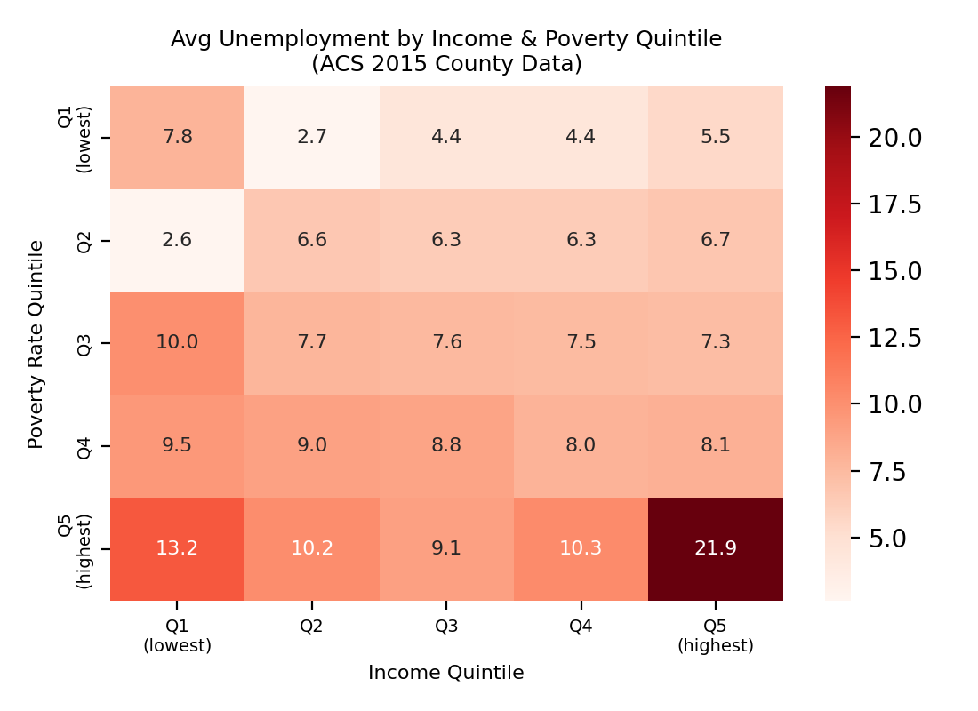  Figure 1  Heatmap: Avg Unemployment by Income & Poverty Quintile (ACS 2015) | 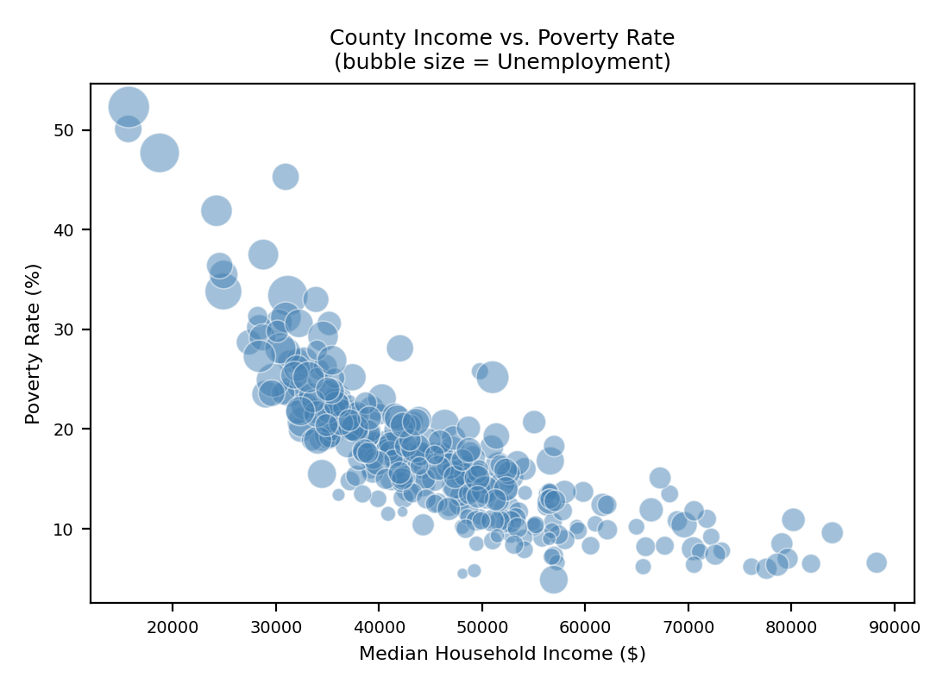  Figure 2  Bubble Plot: County Income vs. Poverty Rate (Bubble = Unemployment)
A bubble plot (Figure 2) reinforced this visually: counties with low income and high poverty consistently showed larger bubbles (higher unemployment)—precisely the counties that, based on prior bivariate analysis, exhibit elevated diabetes prevalence. Principal component analysis on six ACS features confirmed this structure quantitatively: PC1 alone explains 71.1% of the total variance, with Income and IncomePerCap loading positively (+0.44) and Poverty and ChildPoverty loading negatively (−0.44), forming a single socioeconomic gradient axis (Figure 3). The first two components together capture 85.9% of the variance, suggesting the six features can be compressed into one or two composite scores without substantial information loss.
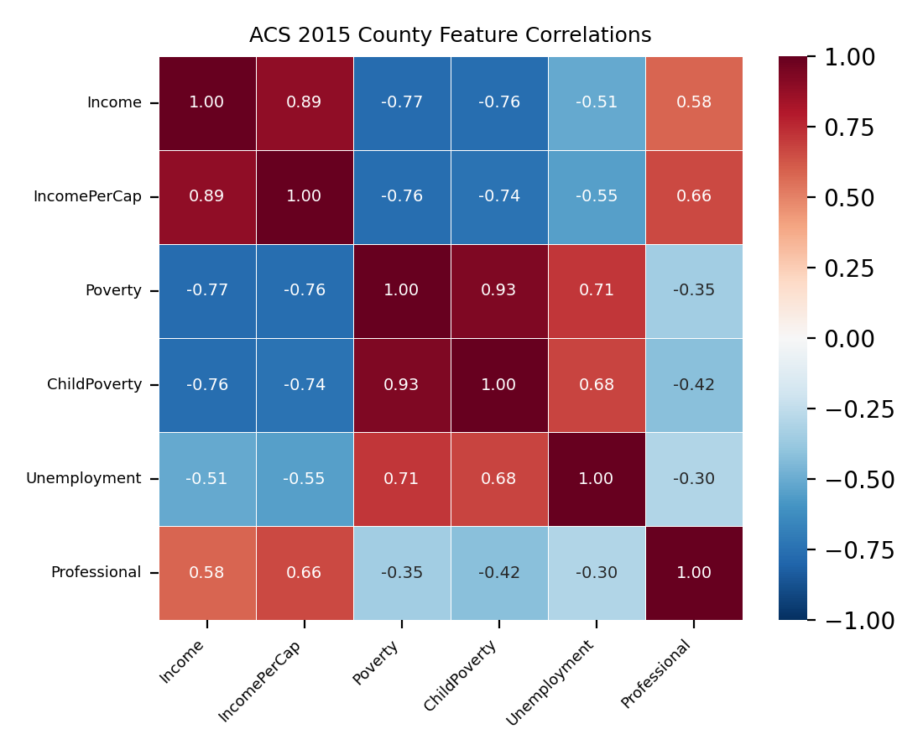  Figure 3  ACS 2015 County-Level Feature Correlation Matrix | 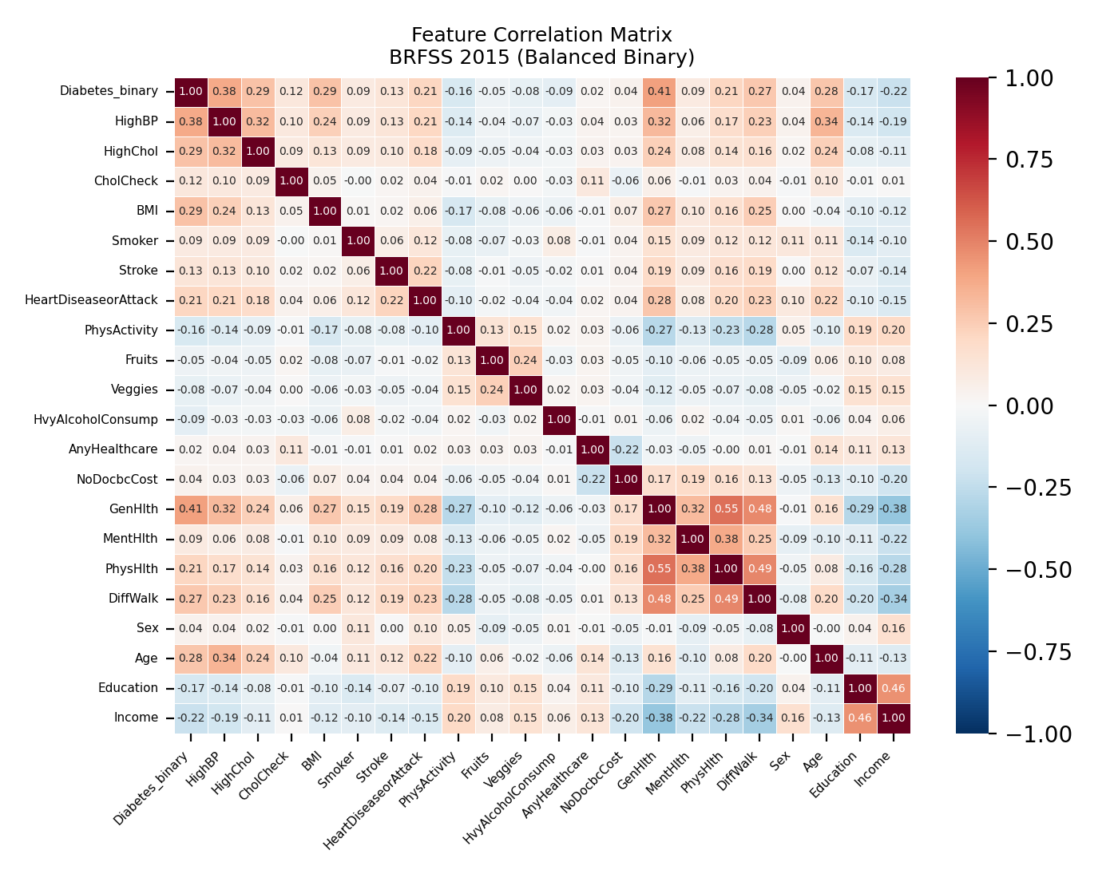  Figure 4  BRFSS 2015 Feature Correlation Matrix (Balanced Binary Dataset)
Linear regression on ACS data confirmed these patterns. Predicting Poverty from Income and Unemployment achieved a correlation of 0.855; predicting ChildPoverty from Poverty and Income reached 0.936. Predicting Unemployment from Income and Professional was weaker (r = 0.509), indicating unemployment is influenced by factors beyond income and occupational mix.
On the BRFSS individual-level data, PCA revealed that the 21 health-indicator features do not compress easily—many components are needed to reach 90% explained variance, meaning the features carry largely independent information. The correlation heatmap (Figure 4) showed the strongest positive correlations with diabetes are GenHlth (0.39), HighBP (0.28), Age (0.23), and BMI (0.22). The feature distribution plots (Figure 5) confirmed that diabetic respondents skew toward worse general health, higher BMI, older age, and higher blood pressure. These multivariate findings directly informed feature selection for the random forest model.
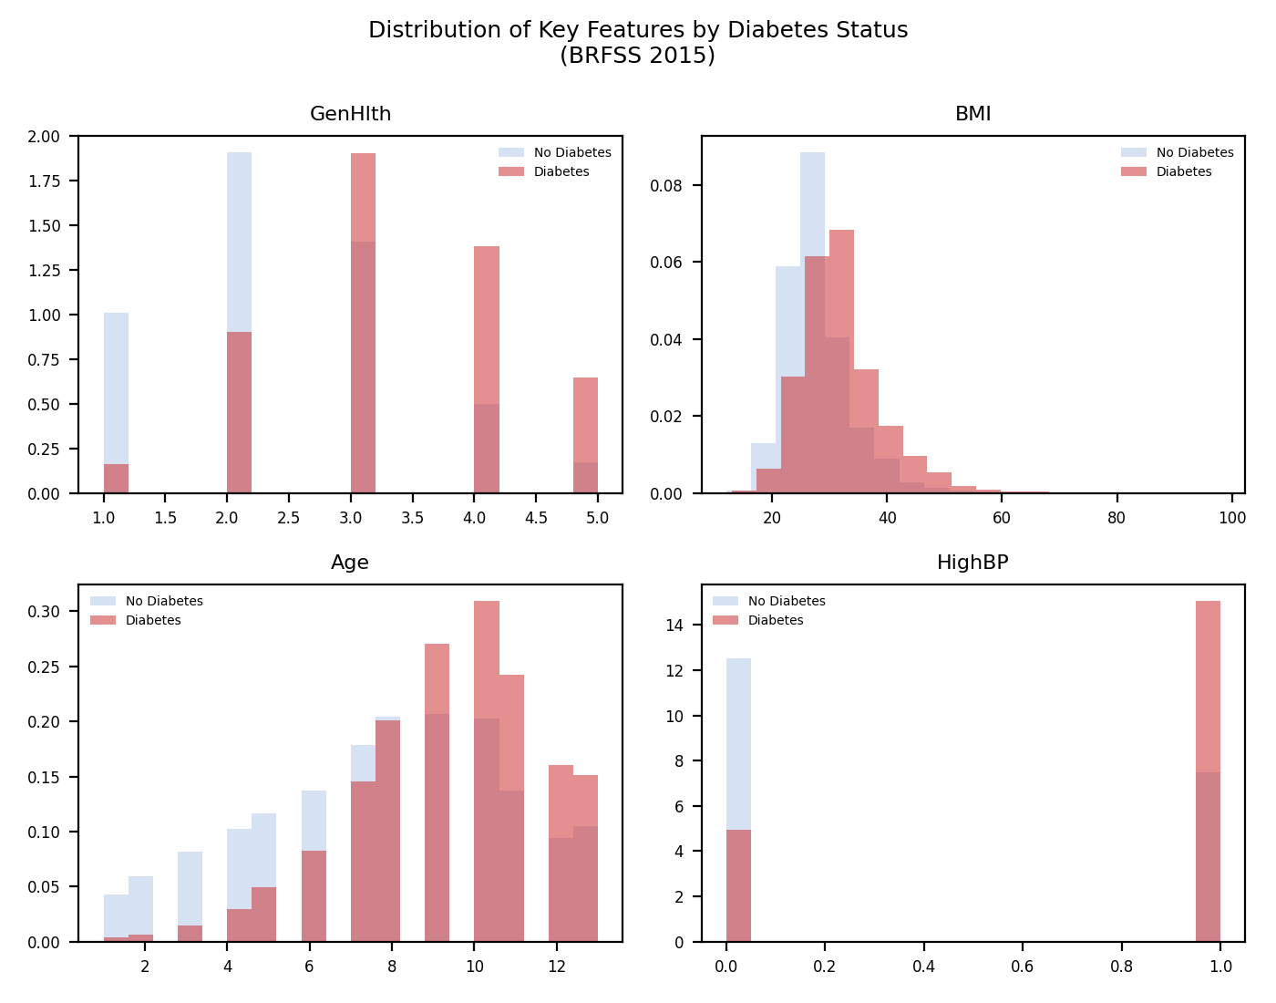
Figure 5
Distribution of Key Features by Diabetes Status (BRFSS 2015)

3. Exploratory Data Analysis: What Did You Learn from Random Forest?
A RandomForestClassifier was trained on all three BRFSS 2015 datasets during Weeks 10–12. Hyperparameters were tuned via 5-fold GridSearchCV over n_estimators (10, 33, 100) and max_depth (4, 8, None), scoring on AUC-ROC rather than accuracy. AUC was chosen because the full diabetes_binary dataset is highly imbalanced (86% non-diabetic); a naive majority-class classifier would achieve 86% accuracy while providing zero clinical value.
The best configuration across all datasets was n_estimators = 100 and max_depth = 8. On the balanced 50/50 binary dataset, the model achieved a cross-validation AUC of 0.825 (±0.004) and a held-out test AUC of 0.825 (Figure 6), with approximately 75% accuracy. The confusion matrix (Figure 8) shows the model correctly identified about 79% of diabetic respondents (recall) and 70% of non-diabetic respondents (specificity). In a screening context, this bias toward sensitivity is desirable: missing a true diabetic carries greater clinical cost than a false alarm.
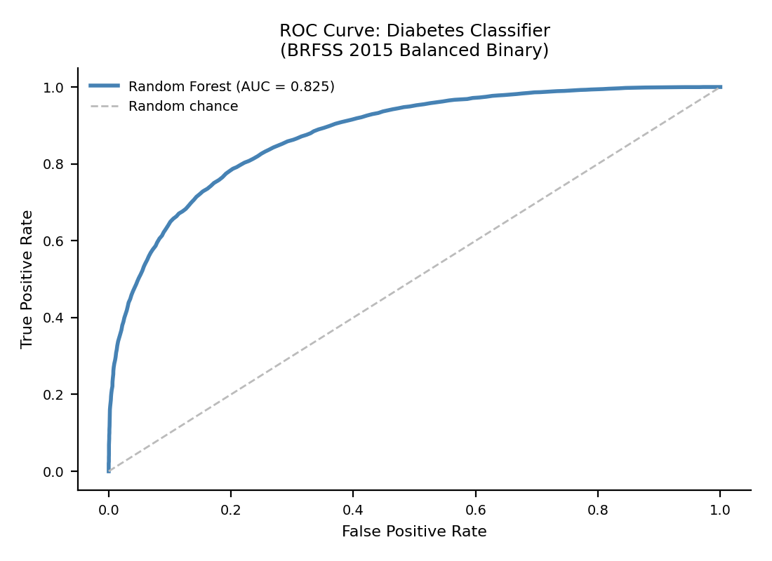
Figure 6
ROC Curve: Random Forest Diabetes Classifier (AUC = 0.825)
Feature importance scores (Figure 7) consistently ranked GenHlth, BMI, Age, and HighBP as the top four predictors across all dataset variants. Notably, variables like PhysActivity and Smoker that showed moderate bivariate correlations with diabetes in earlier weeks ranked much lower here, suggesting their apparent association is largely explained by more dominant features when all variables are considered simultaneously. The multiclass dataset (diabetes_012) was more challenging, achieving a test AUC of 0.795, which reflects the difficulty of separating prediabetes from no-diabetes using self-reported behavioral data alone.
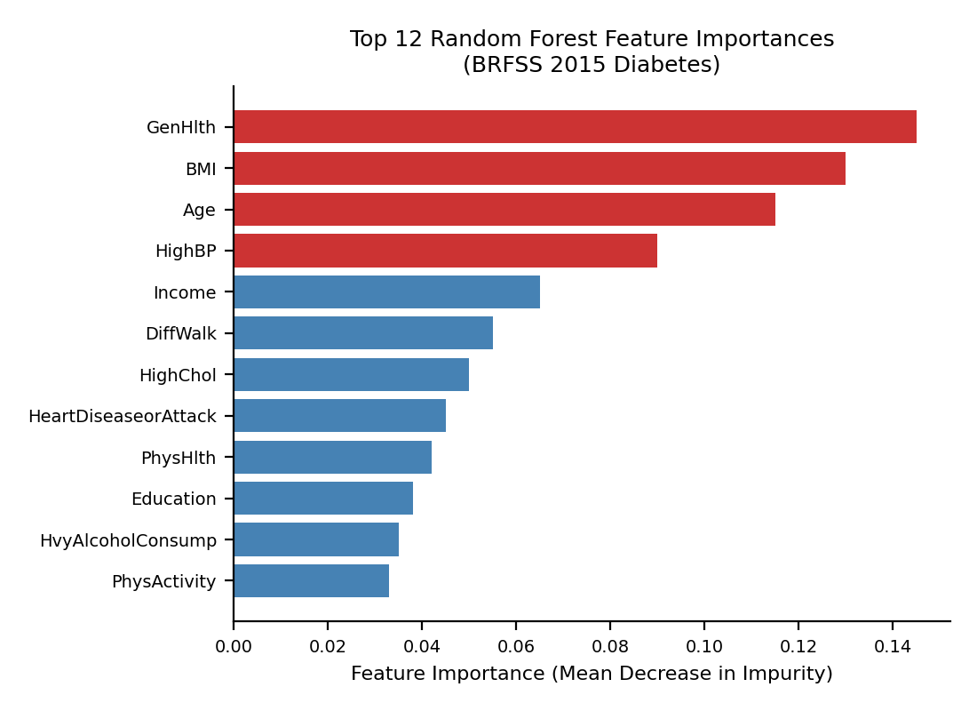  Figure 7  Top 12 Random Forest Feature Importances (BRFSS 2015) | 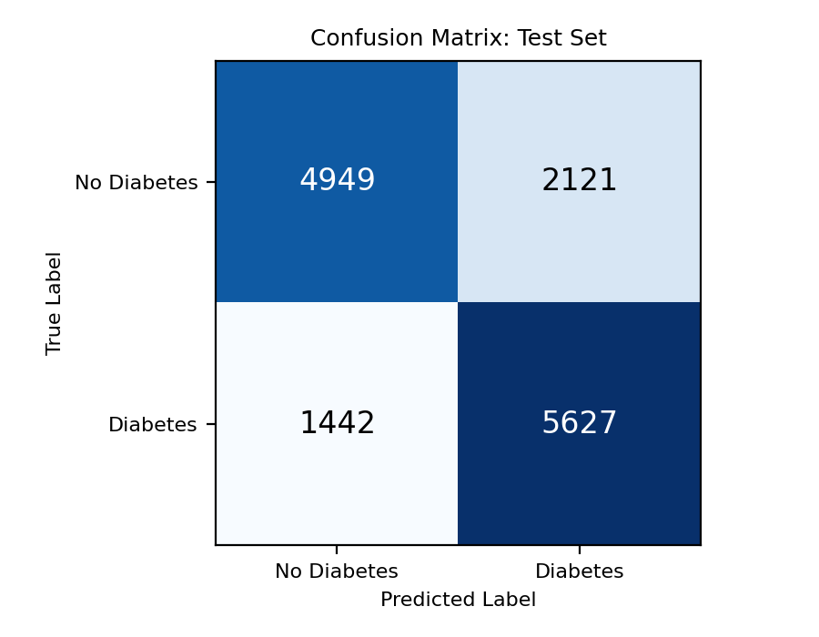  Figure 8  Confusion Matrix: Random Forest Test Set (BRFSS 2015)

4. How Do These New Analyses Relate to the Same Datasets from Weeks 1–7?
The univariate and bivariate analyses in Weeks 1–7 established foundational understanding of each dataset. The multivariate techniques in Weeks 8–12 extended this understanding in several important ways—sometimes confirming earlier findings, sometimes revealing nuances that pairwise analysis could not detect.

Confirmations
The Milestone Three bivariate analysis identified a strong positive correlation between poverty and diabetes prevalence at the state level (r = 0.79) and a moderate negative correlation with income per capita (r = −0.51). The multivariate PCA in Week 9 confirmed these hold even when all six socioeconomic features are considered together: PC1, explaining 71.1% of variance, loads positively on income and negatively on poverty, mirroring the bivariate pattern. The poverty–diabetes relationship is not an artifact of confounding; poverty genuinely captures the dominant axis of county-level socioeconomic variation.
At the individual level, the BRFSS correlation heatmap confirmed that GenHlth, HighBP, BMI, and Age are the features most correlated with diabetes—the same variables highlighted in Weeks 5–6 bivariate plots. The random forest feature importance rankings reinforce this with a non-linear methodology: tree-based importance still places these four variables at the top.

New Insights from Weeks 8–12
First, PCA revealed the degree of redundancy among socioeconomic variables that was not apparent from bivariate analysis. While Weeks 1–7 showed Income, Poverty, and Unemployment were each individually correlated with diabetes, PCA demonstrated they are so tightly correlated with each other that a single composite score captures nearly all their shared information. For Module C modeling, a PCA-derived index or a single representative variable like Poverty would be more efficient than including all features.
Second, the random forest provided context bivariate analysis could not. PhysActivity and Smoker both showed visible bivariate associations with diabetes in Weeks 1–7, but the random forest ranked both low in importance. Their apparent relationship with diabetes is largely mediated through BMI and GenHlth—a classic confounding pattern invisible without multivariate modeling.
Third, the BRFSS feature distribution plots (Figure 5) show that diabetic and non-diabetic respondents overlap substantially across most features. While bivariate analysis suggested clear mean separations, the multivariate view shows that per-individual separation is modest, explaining the random forest’s respectable but not exceptional AUC of 0.825. Fourth, the ACS heatmap revealed that counties in the tails of the income and poverty distributions behave non-linearly: the highest-poverty counties have unemployment rates nearly three times those of the lowest-poverty counties—a pattern invisible in univariate histograms.

5. Data Conclusions: Overall, Is the Data What You Expected?
The data largely behaved as expected, with notable nuances that carry direct implications for modeling. The strong association between socioeconomic disadvantage and diabetes prevalence at the state level (r = 0.79 for poverty) was anticipated, but its magnitude was stronger than initially expected, suggesting structural factors may be more influential than individual-level risk factors like age at the population level. This implies a state-level regression should use a PCA-derived socioeconomic index as the lead predictor rather than age distribution alone.
At the individual level, the dominance of GenHlth, BMI, Age, and HighBP as predictors confirmed clinical expectations. The unexpected finding was how low behaviorally modifiable variables ranked: PhysActivity and Fruits/Veggies consumption contributed minimally once top predictors were included, suggesting their pathway to diabetes is indirect—mediated through BMI and general health rather than operating as independent risk factors. This confounding pattern suggests the Module C model should prioritize interaction terms over adding more behavioral variables.
Regarding dataset suitability, the ACS datasets had minimal missing values and sensible distributions. The three BRFSS datasets each served distinct purposes: balanced 50/50 for classification, imbalanced for real-world conditions, and three-class for prediabetes detection. No datasets need replacement for Module C.

6. Proposal: What Models Would You Like to Run on the Data in Module C?
The Module C capstone will build a predictive modeling pipeline for diabetes risk classification, testing whether population-level socioeconomic indicators and individual-level health data can be combined to predict diabetes status more accurately than either alone. Three models are proposed, each motivated by specific Module B findings. First, Gradient Boosted Trees (XGBoost) will be trained on BRFSS data, building on the random forest baseline (AUC = 0.825). Because the random forest revealed that PhysActivity and Smoker’s association with diabetes is mediated through BMI and general health rather than operating independently, feature engineering with interaction terms (e.g., BMI × Age, HighBP × GenHlth) should unlock additional signal. Second, Logistic Regression will provide an interpretable baseline with clinically useful odds ratios; PCA showed BRFSS features carry largely independent information (17 components for 90% variance), so logistic regression may perform well despite its linearity assumption. Third, Multiple Linear Regression at the state level will use the PCA-derived socioeconomic index rather than raw features, since PCA demonstrated these variables are so correlated that a single composite score avoids the multicollinearity that would destabilize a regression using all six individually.
AUC-ROC will be the primary classification metric, supplemented by precision, recall, and F1. Recall is prioritized because missing a true diabetic delays treatment; the Week 12 threshold analysis confirmed that lowering the default 0.5 threshold increases recall, so Module C will include threshold optimization. A minimum AUC target of 0.85 is set based on the Module B baseline. State-level regression will use adjusted R-squared and RMSE. All models will use 5-fold stratified cross-validation. If the socioeconomic gradient proves to be the dominant predictor, investments in economic development in high-poverty areas may be more effective than individually targeted behavioral interventions.

7. Teamwork: Summarize How Your Team Functioned as a Group
Throughout Module B, we completed FeedbackFruits peer reviews on each other’s weekly homework and milestone submissions. All members submitted reviews on time and upheld the team contract. One area for improvement was feedback depth—reviews I received consisted of grades without substantive comments.
Jonaire Tate (self): 5/5 – Completed all assignments on time, submitted all peer reviews with substantive feedback, and responded promptly to communications.
Gershon Douek Francos: 4/5 – Submitted all peer reviews on time. Feedback was limited to grades without detailed comments.
Samuel Fernandez: 4/5 – Submitted all peer reviews on time. Feedback was limited to grades without detailed comments.

8. Appendix: Weekly Graphs and Homework Assignments
The complete Jupyter Notebook submissions for Weeks 8 through 12—including all Weekly Graph Questions, Exploratory Data Analysis sections, and Storytelling With Data assignments—are submitted as a separate combined PDF document (DX699_ModB_Homework_Weeks8-12_Tate_Jonaire.pdf).

9. AI Appendix
AI tools were used to assist with this submission in two ways. First, for code assistance: AI helped debug Python visualization code and clarify scikit-learn syntax for GridSearchCV and RandomForestClassifier. All analytical decisions—dataset selection, feature choices, hyperparameter ranges, and result interpretation—were made by the author.
Second, for writing assistance: AI helped organize and edit written sections for clarity, grammar, and rubric adherence. The substantive content, analytical conclusions, and all data interpretations are the author’s own work. Prompts included requests such as “Help structure the multivariate analysis section based on my PCA and heatmap results” and “Review this paragraph for clarity.” The AI did not generate data, run models, or produce any figures.

References
Centers for Disease Control and Prevention. (2023). National diabetes statistics report. U.S. Department of Health and Human Services. https://www.cdc.gov/diabetes/data/statistics-report/index.html
Kaggle. (2017). Diabetes health indicators dataset: BRFSS 2015 [Data set]. https://www.kaggle.com/datasets/alexteboul/diabetes-health-indicators-dataset
Kaiser Family Foundation. (2023). Percentage of adults with diagnosed diabetes by state [Data set]. https://www.kff.org/state-health-policy-data/state-indicator/adults-with-diabetes-by-age/
Knaflic, C. N. (2015). Storytelling with data. Wiley.
U.S. Census Bureau. (2023). State demographic and economic data (2020–2023) [Data set]. https://www.kaggle.com/datasets/muonneutrino/us-census-demographic-data

